**Introduction to BDD**

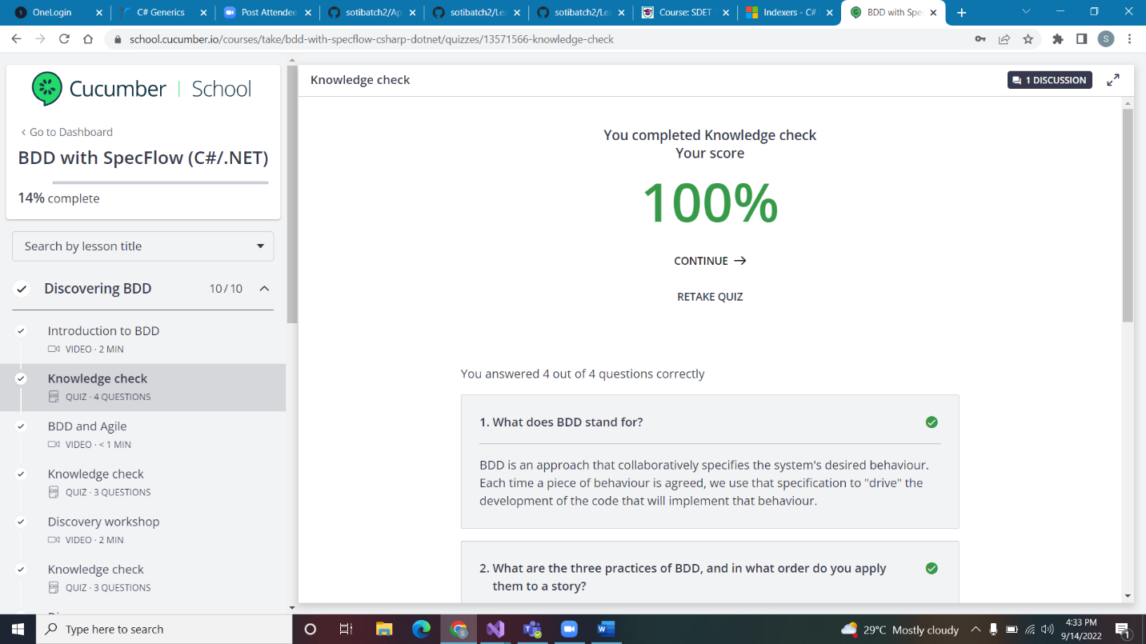

### BDD and Agile

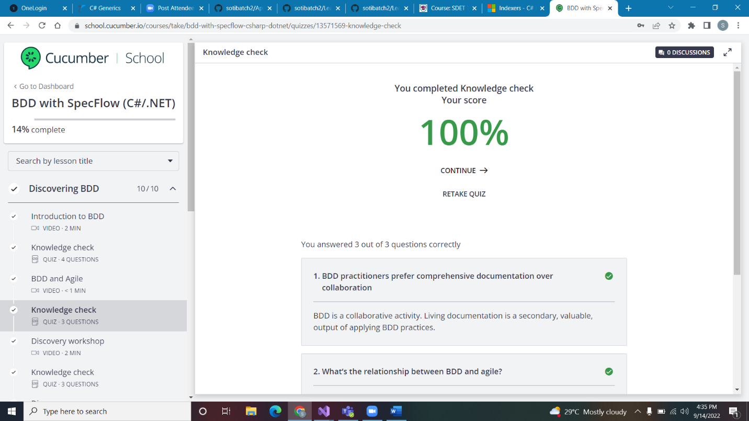

### Discovery workshop

### Discovery summary

### Introduction to formulation

